# Heuristic Evaluation – Gempots.com

Heuristic Evaluation (HE) is typically done on major elements of the application. This is an example of the application of a HE to a design interface. The HE evaluation is typically done by working through the system and evaluating based on a number of evaluation criteria;

1. Visibility – The system provides visibility of system status and gives adequate user feedback
2. Metaphor – A match between system and the real world or user understood system exists
3. Control – The user has control of system and freedom to perform tasks as needed
4. Consistency – Application behaves consistently to user interaction
5. Standards – The application flows and uses industry standard UI design
6. Errors – The App controls input as to limit errors
7. Recognition – System uses principle of recognition and requires minimal recall
8. Flexibility – The system provides flexible mechanisms for advanced users
9. Minimalism – The system provides enough, but not too much information or capability
10. Recovery – The system helps users Recognize/Diagnose/Recover from errors
11. Help – Necessary help and documentation is easily accessible.

## Gemspots.com Main Screen – analysis done on PC using Firefox browser

The first attempt to access the main screen of Gempots.com gave the following error message.

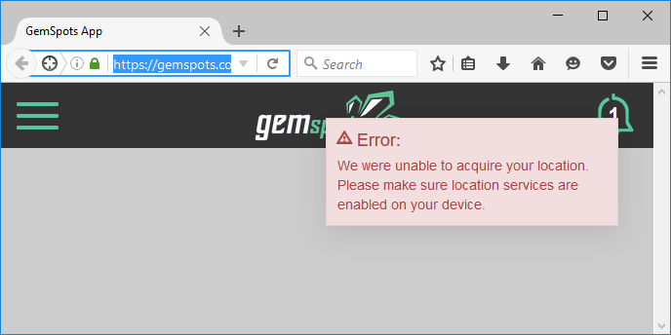

The clearing of the error message was easy as hovering over the error dialog did provide a X to close the error. However, the clearing of the error left a blank screen – with no error message or other further user instructions. In compliance with **Item 10 – Recovery**, additional instructions might be needed for the novice user to know how to handle the error message.

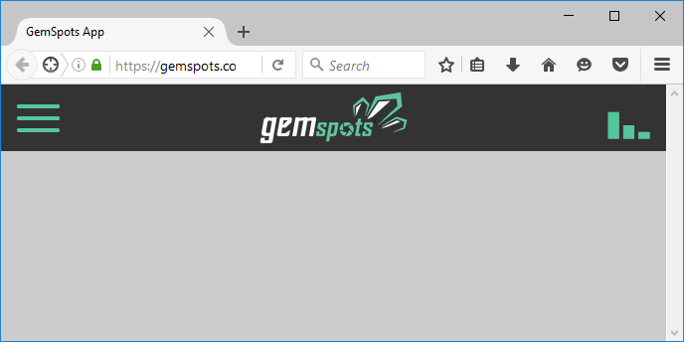

**Item 1 – Visibility, Item 10 – Recovery**: If the App requires location services for the functionality of the App, but allows for limited functionality for the user if location services are not available provide this feedback to the user as per item 1 Visibility. The App goes to a blank screen once the error message is cleared if no location services are available. Selecting Update Location from the Menu (Hamburger menu) did clear and provide an interface as shown.



**Item 2 – Metaphor** – At this stage the system does not provide a sufficient metaphor to determine the purpose of the App. Hover over various icons did not provide feedback on the purpose of the icons or provide a sufficient user metaphor to determine the purpose of the App. The icons do suggest click or touch on them based on standard Windows 8 and Windows 10 (**Item 5 – Standards**) In addition the cursor changes to a “click” hand on hovering over the icons as per (**Item 5 – Standards**) also providing indication that the icons are clickable. There is minimal indication that the application is a photo gallery based application (**Item 1 – Visibility**). Resolution of this item might also provide a higher level of Item 2- Metaphor to the user to understand the purpose of the App.

ACTION – Click on Popular Spots Green Icon

The action of clicking on the Square Green Icon title Popular Spots provided no results. This is in violation of **Item 5 – Standards** – the icon indicates a potential of being clickable and the icon on hover does change to be a hand. However, no action results.

ACTION – Click on Photo

Clicking on a photo yields results of changing the screen to a photo gallery. The gallery does give an introduction screen – which is a positive on **Item 1- Visibility**.

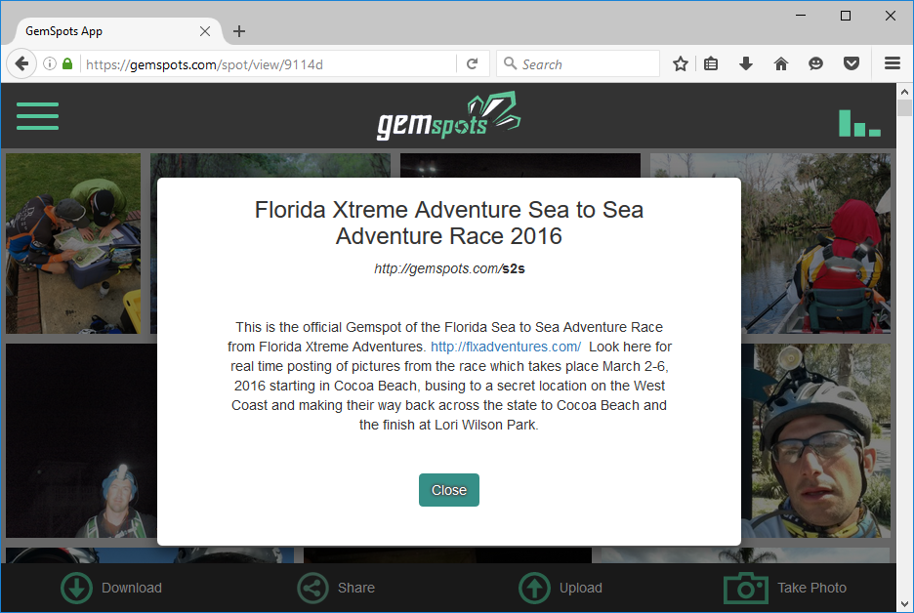

Clicking the close button closes the introduction box and presents a Photo Gallery which is very recognizable under **Item 2 – metaphor**. The majority of users should have a level of familiarity with Photo Gallery applications and this can be confirmed by the creation and use of a user survey to validate this. The gallery is shown.

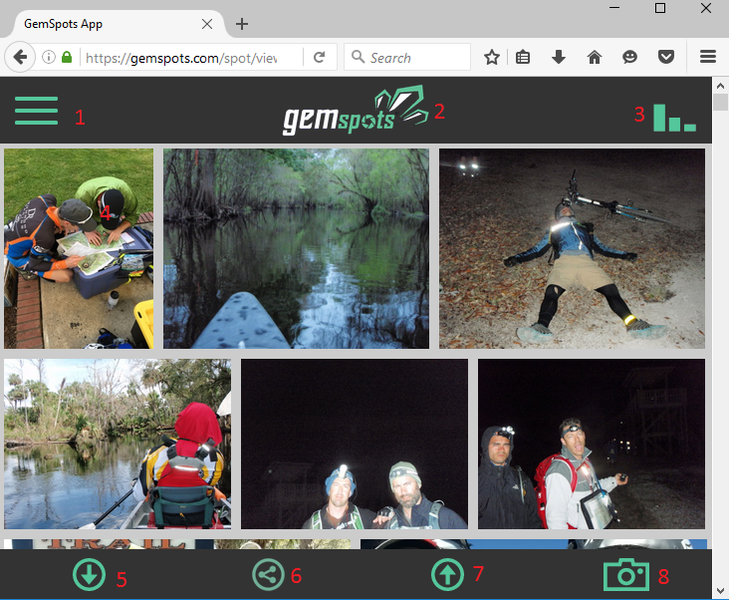

Hovering over the various icons yields the following results

ACTION – Hover over Item 1 – Icon changes to hand, No description (Violation – Visibility)

ACTION – Hover over item 2 – Icon changes to hand, No Description, URL shown left (Violation – Visibility)

ACTION – Hover over item 3 – Icon changes to hand, , Information box “Connected to Gempsots.com” shown.

ACTION – Hover over item 4 – Icon changes to hand, Select Box presented on top of photo.

ACTION – Hover over item 5 –

(note the evaluation will continue for all hover actions)

ACTION – Click on Item 1 –

(You will continue for all click actions)