**DETENTION METHODOLOGY**

**How does the program calculate the average annual effectiveness for detention systems?**

A detention system is one that removes pollution by holding water before discharge to a surface water. Examples are wet ponds, detention depression areas, and baffle boxes, to mention a few. For wet ponds, the average annual effectiveness is calculated using the permanent pool volume. The permanent pool volume divided by the annual runoff is defined as the annual residence time, and typically is referred to as detention time.

Annual Residence Time (days) =[Permanent Pool (Ac-Ff)/Annual Runoff Off (Ac-Ft/yr)] x 365 d/yr

Annual runoff is calculated as the sum of runoff from each and every storm event over the periods of simulation (normally greater than 15 years). The calculation for annual runoff is shown in the support information on the watershed characteristics worksheet.

The annual residence time is related to the average annual removal using the following relations. The removal curves reflect the mechanisms for removal of particulates as well as dissolved nutrients. These curves were developed by Harper and Baker (2007), Evaluation of Current Stormwater Design Criteria within the State of Florida, Final Report submitted to the Florida Department of Environmental Protection for Agreement SO108.

For Nitrogen:

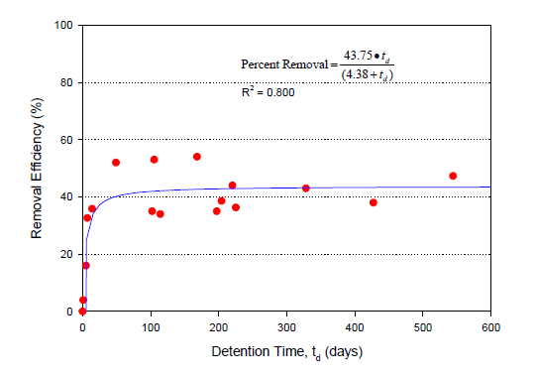

For Phosphorus:

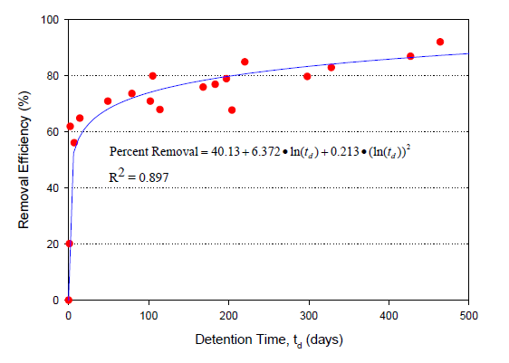

A nitrogen removal plot for 31 days of annual residence and for a particular catchment configuration is shown as:

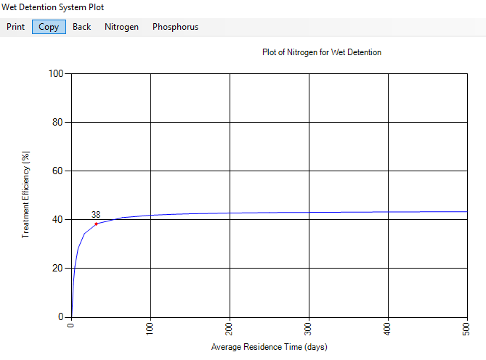

Within the same catchment, the land use may dictate a series of larger ponds inter connected but with no additional input between the ponds. For this case, the removal effectiveness is based on the sum of the annual residence time. Thus, the mechanisms for removal are not counted twice. It is not the sum of each pond effectiveness. For the case of nitrogen, the incremental removal obtained by increasing the permanent pool using a series of ponds is improved but by a small fraction compared to the increase in the permanent pool (or average annual residency time). This is shown in the attached plot for nitrogen when the series of ponds increases the residence time to 100 days. To increase the residency time from 31 days to 100 days requires more than a 3 fold increase in pond volume.

