|  |
| --- |
| **MASS LOADING METHODOLOGY:** |
|

**What is mass loading?**

Mass loading is the product of concentration and runoff volume. The typical measurement units used are kilograms per year or pounds per year. The typical units for concentration are milligrams pe liter. Runoff volume is yearly average and expressed usually in acre-feet or million gallons. Mass Loading is calculated as an average annual loading, thus average annual runoff and average annual concentrations are used.

**How is mass loading calculated?**

Average annual loading is calculated as the product of the average Event Mean Concentration (EMC) and the average annual runoff. The EMC will vary with the land use. The average annual runoff varies with the average annual rainfall and the land use characteristics. The land use characteristics are defined by the directly connected impervious area (DCIA) and the rainfall excess from the non-directly connected impervious area. The non-directly connected impervious area (NDCIA) is defined by the composite curve number (CCN) for that area. The curve number (CN) for each NDCIA is weighted by the annual runoff to calculate the CCN.

The annual runoff calculations are based on long term simulations (greater than 25 years) using the DCIA and the CCN for the NDCIAs. These have been reported for 5 meteorological areas (defined by common rainfall inter event dry periods) as shown in support data files on this worksheet. One-hundred Sixty (160) rainfall stations (111 in the state) were used to generate annual runoff for stated land use conditions. Tables for the percentage of runoff for combinations of the CN for NDCIA and DCIA were developed and reported by Harper and Baker (2007), Evaluation of Current Stormwater Design Criteria within the State of Florida, Final Report submitted to the Florida Department of Environmental Protection (FDEP) for Agreement SO108. Another source of information is found in a draft rule developed by a FDEP task force and published in 2010. Both of these publications are reproduced here as Harper Methodology and Draft Rule.

**How is average annual runoff calculated?**

The annual runoff is the fraction of rainfall resulting from all storm events during the simulation years divided by the number of years. This is expressed in units of inches over the catchment. In more familiar units of measurement, inches is multiplied by the catchment area (acres) and divided by 12 inches per foot to express the average annual runoff in units of acre-feet.

The average annual runoff coefficients (fraction of rainfall) are viewed using the support data found on the “watershed characteristics page, adjacent to the Annual C printout data. When the CN and the DCIA are not in 5 unit increments, a linear interpolation method is used to calculate the value. The average annual runoff is calculated from each rational C table by a “look up” method. An example of average annual runoff fractions for a meteorological region is:

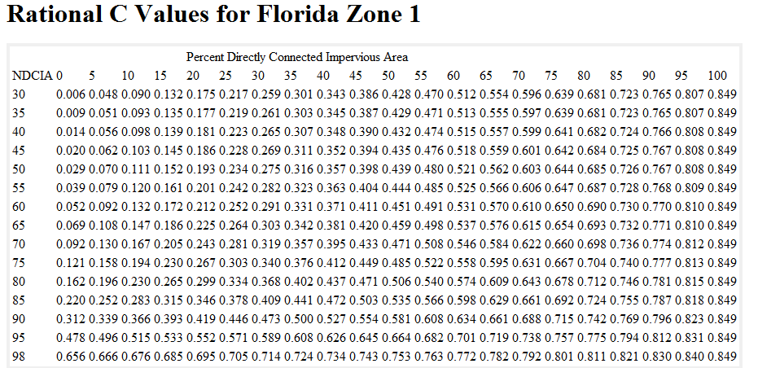

**What are Event Mean Concentration (EMC) data?**

EMCs are available for each land use and they are found in support information and are listed once a land use is picked. Also a user defined value is permitted. An example of the EMCs are:

|  |  |  |  |
| --- | --- | --- | --- |
|  | LAND USE CATEGORY | Event Mean Concentration (mg/l) | |
|  |
|  | TOTAL Nitrogen | TOTAL Phosphorus |
|  |
|  | AG - CITRUS | 2.240 | 0.183 |
|  | AG - GENERAL | 2.8 | 0.487 |
|  | AVERAGE OF MFR+UNDEVELOPED | 2.320 | 0.520 |
|  | AVERAGE OF SFR + UNDEVELOPED | 2.07 | 0.327 |
|  | DRY PRAIRIE* | 2.025 | 0.184 |
|  | HIGH INTENSITY COMMERCIAL | 2.4 | 0.345 |
|  | HIGHWAY | 1.52 | 0.2 |
|  | HYDRIC HAMMOCK* | 1.288 | 0.107 |
|  | INDUSTRIAL | 1.2 | 0.26 |
|  | LOW DENSITY RESIDENTIAL | 1.645 | 0.270 |
|  | LOW INTENSITY COMMERCIAL | 1.130 | 0.188 |
|  | MESIC FLATWOODS* | 1.090 | 0.043 |
|  | MINING | 1.180 | 0.150 |
|  | MULTI FAMILY RES | 2.320 | 0.520 |
|  | PASTURE | 3.510 | 0.686 |
|  | ROW CROPS | 2.650 | 0.593 |
|  | RUDERAL UPLAND PINE* | 1.694 | 0.162 |
|  | SCRUBBY FLATWOODS* | 1.155 | 0.027 |
|  | SFR OR MFR DEPENDING ON UNITS | 2.070 | 0.327 |
|  | SINGLE FAMILY RES | 2.070 | 0.327 |
|  | UNDEVELOPED | 1.288 | 0.107 |
|  | UNDEVELOPED User Defined (overwrite defaults) | User input | User input |
|  | WATER | 0 | 0 |
|  | WET FLATWOODS* | 1.213 | 0.021 |
|  | WET PRAIRIE* | 1.095 | 0.015 |
|  | WETLAND* | 1.15 | 0.055 |
|  | XERIC HAMMOCK* | 1.288 | 0.107 |
|  | XERIC SCRUB* | 1.288 | 0.107 |