**RETENTION METHODOLOGY**

**How does the program calculate the average annual effectiveness for retention systems?**

The average annual effectiveness is calculated using an event maximum runoff volume that can be captured in the retention system. This maximum volume is expressed as inches over the catchment area and is called the design volume. Thus it is adjusted for the Curve Number (CN) applied to the non-directly connected impervious area (NDCIA) and the directly connected impervious area (DCIA). The annual capture effectiveness varies with the rainfall volumes. The runoff volume is recovered in 72 hours.

A plot of average annual removal effectiveness as a function of rainfall for specific watershed conditions and rainfall zone is shown below. At one inch of treatment, the average annual effectiveness is 81%. When another retention systems follows at 1.0 inch, making a total retention of the water from the same catchment equal to 2.0 inch, the average annual effectiveness is about 92%. It is not 2 x 81%.

There are data to calculate the average annual effectiveness for up to 4 inch of retention. At 4 inches, the effectiveness is near 99% for most catchment conditions. Any retention volume above 4 inches is assigned the maximum removal at 4 inches. If the treatment retention volume(s) are above 4 inches, for average annual effectiveness the retention area is considered to be subtracted from the total area. Four inches of retention storage is one way to reduce the directly connected impervious area.

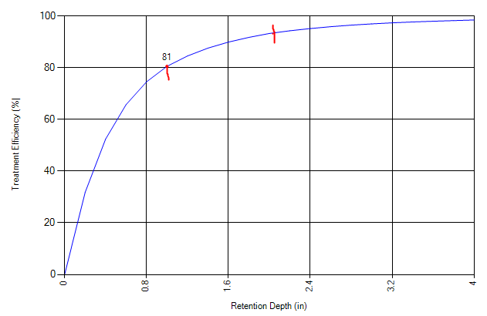

92

The source of the capture volume data and curves is: Harper and Baker (2007), Evaluation of Current Stormwater Design Criteria within the State of Florida, Final Report submitted to the Florida Department of Environmental Protection for Agreement SO108.

There are 80 tables reflecting design retention depths for five rainfall regions. Each region has a table for 17 different design retention depths. An example of one of 80 tables reflecting the capture volume percentage as a function of CN and DCIA for a design depth of 0.5 inches is shown below. For DCIA and CN other than increments of 5, linear interpolation between the values is performed. These tables for each meteorological region and retention depths are found in the “tools” section.

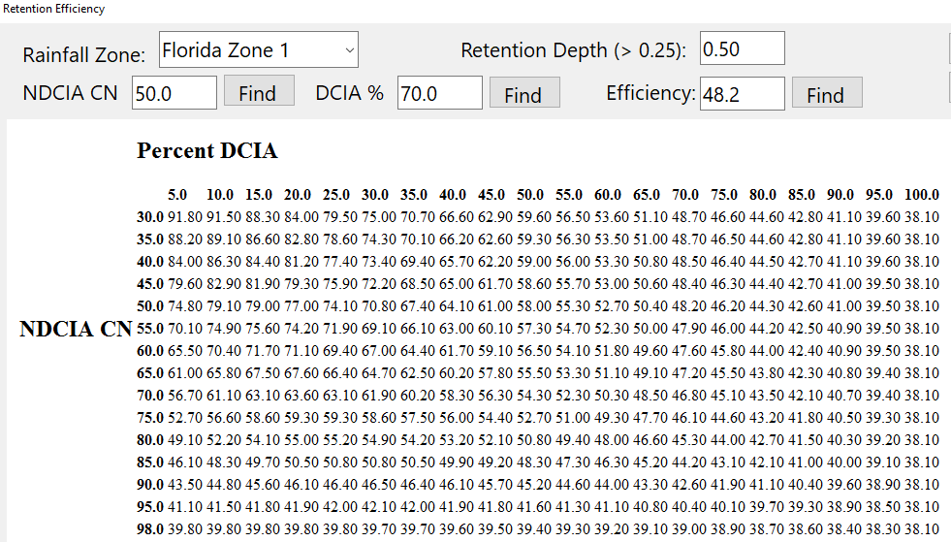

The calculation aid in “tools” is labeled as “retention efficiency lookup tables”. The “tools” button on the “select treatment options” worksheet is used. To examine the variability in the average annual effectiveness, this calculation aid can be used.

For a design depth of 0.75 inches, the capture volume percentage as a function of CN and DCIA is:

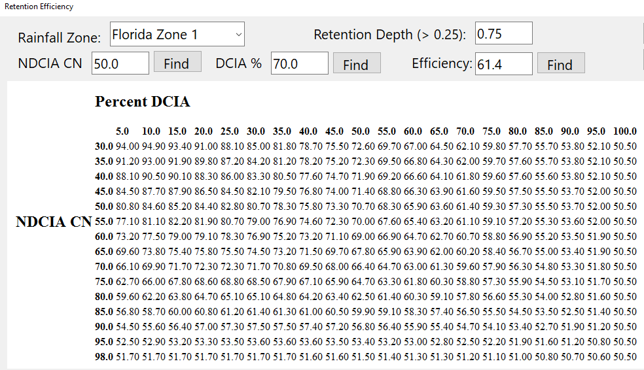

As another example when tables are not available, interpolation between the tables is done. if the NDCIA CN were 40 and the DCIA were 25, and the design retention is 0.75 inch, the capture is 86%. For a design depth of 0.50 inch, the capture is 77.4%. If the design volume were 0.625 inch (midway between the table values), the removal is 81.7%.

